WHAT’S HAPPENING THIS MONTH – SEPTEMBER 2019

Approval of Stream 1 Planon Functionality for Go Live

August was a pivotal period for EMMS with the emphasis on High Level Design and operational decisions to guide the implementation of Planon. In September, EMMS will finalize which Planon functionality will go live in Stream 1, April 2020 and remaining functionality for deployment in Stream 2, September 2020 in consultation with Phase 1 stakeholders.

Prior to finalizing these decisions in mid-September, the Process & Outcomes Committee will weigh the need for operational continuity, opportunities to introduce new mobile capabilities for field staff and quick wins offered by adopting Planon recommended processes. September officially marks the beginning of the Configure & Prototype stage. EMMS will work with Phase 1 stakeholders to determine how Planon will be configured for maintenance, inventory and asset management activities for Go Live via two configuration iterations.
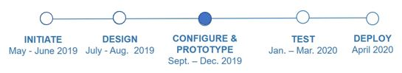
The main activities in September include:
- Finalize the Project Plan timelines, milestones and deliverables for Stream 1
- Communicate the scope of the functionality and the total number of Phase 1 stakeholders that will be impacted (dependent on scope of Planon functionality)
- Continue with data management and integration activities working with internal teams at UBC to ensure alignment with other initiatives including Workday

Deliverables this Month
- Final approval from the Steering, Process & Outcomes Committee on Stream 1, 2 scope.
- Finalize EMMS Project Plan and share a roadmap of what to expect in the coming months.

