WHAT’S HAPPENING THIS MONTH – MAY 2019

Getting Ready for Planon’s Initiate Phase
With the ink dry on the Planon contract, the EMMS team is gearing up to welcome Planon to UBC the week of May 21st. After months of discussions and documenting how we do things today, we’re excited to reach the starting line to imagine how we’ll work in the future using Planon.
During the Initiate Phase, the focus is a deep dive understanding of Planon’s features and functionality to evaluate how UBC can leverage best practice business processes. From a project perspective, we’ll collaborate with Planon to develop a project plan to guide our activities in the coming year.
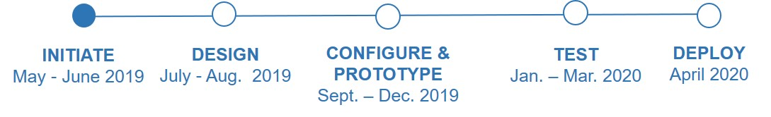

Activities and Timeline
Phase 1 participants in the May to August time frame include: Process and Outcomes Committee (POC), Business Functional Leads (BFL), Subject Matter Experts (SMEs).

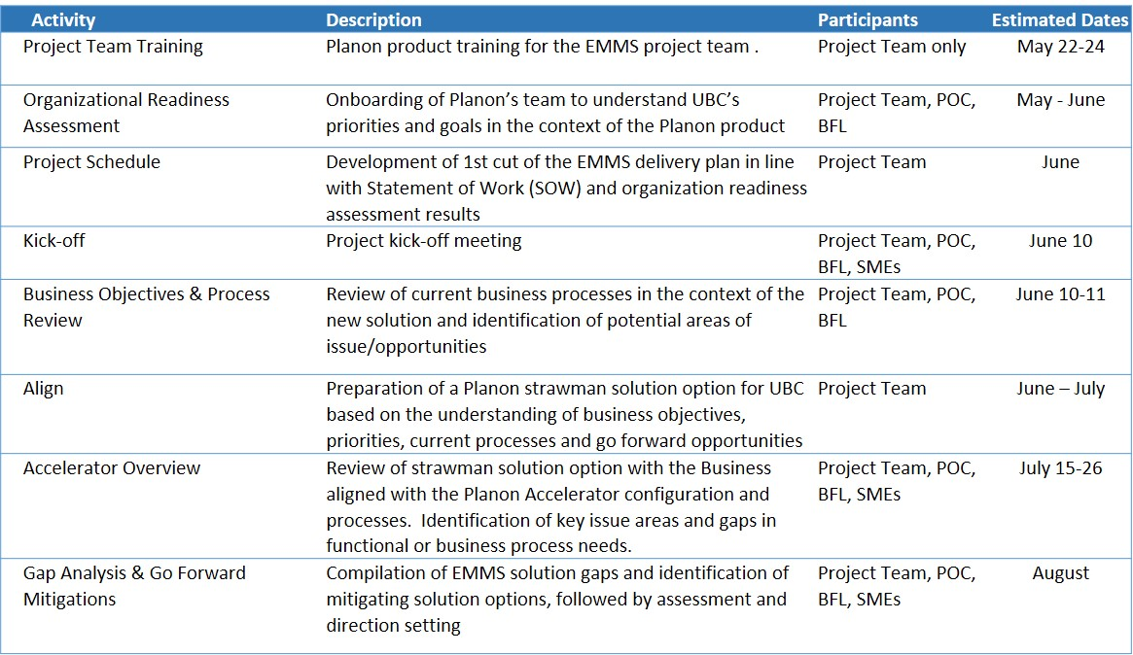
An implementation roadmap will be shared with the campus community when available. Check back often to watch for opportunities to get involved and to learn more about the benefits of Planon to UBC’s operations.

Deliverables this Month
- EMMS internal team kick-off with Planon to onboard consultants on Phase 1 stakeholders, current operating environment and key challenges and opportunities
- Planon training for EMMS team members to learn about its features and functionality in advance of Accelerator workshops in July

