WHAT’S HAPPENING THIS MONTH – APRIL 2019

Understanding How We Do Things Today

The Facts
- Workshop Focus: Current State Process Mapping for Phase 1 stakeholder groups
- Who: Phase 1 Stakeholders including staff in Building Operations, Energy & Water Services, Chemistry Stores
- What: Document current process, identify pain points and value-added activities
- When: Workshops held between March and May 2019
- Why: By understanding current processes i.e. how we do things today, UBC will be able to leverage Planon functionality to streamline processes, where appropriate, and take advantage of new features to improve operational effectiveness and the customer experience.
- Total Workshops: 35
- Process Areas: 28
- Participants: 65+
- Who: Subject matter experts i.e. Managers, Heads, Sub-heads, People and Process Managers, Store persons, Clerks, Coordinators, Technical Specialists

The Approach
Workshop participants provided details of their current processes which were captured like this:
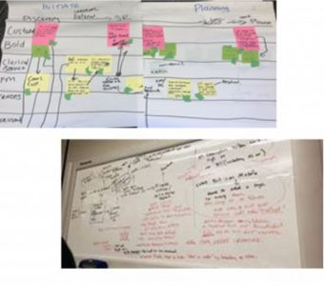

The Outcome
The EMMS Team translated the workshop flowcharts and workshop notes to this:
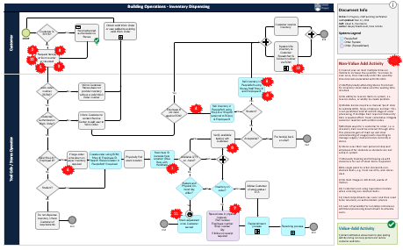

Next Steps
- Current state process maps will be signed off by Business Functional Leads for each process area.
- Validated process maps will be shared with Planon to accelerate their understanding of UBC’s operational environment.
- UBC will explore Planon’s best practice processes in the context of UBC’s current state processes to determine the gaps.
- During the Design phase, UBC will determine the Planon configurations that may be required to meet UBC’s operational needs.

Thank You
A big thank you to workshop participants for making time in your busy schedules. Your input and insights are vital to help us determine opportunities to improve our future state. Special thanks to Hayley MacDonald and Evan Colville for leading these workshops which were often lively as participants debated how we do things today. Patrick O’Connell and Ron Hing played a key role in documenting the workshop outcomes. This is a major accomplishment and completed in record time.

Determining What’s In and Out of Scope
Concurrent with process mapping workshops, EMMS team members are working with Planon to confirm the scope and deliverables. Scope decisions will be validated with Business Functional Leaders and approved by the Steering, Process and Outcomes Committee. This is an important step to ensure everyone understands what will be delivered within the specified timeline. Check back in June when a high-level project plan will be published.

Deliverables this Month
- Process mapping creation and validation with Business Functional Leads
- Creation of EMMS scope document for review with Process and Outcomes Committee and Business Functional Leads
- Preparation for Planon arrival in May

